**DATA ANALYSIS AND INTERPRETATION - SPSS ANALYSIS**

**FREQUENCY Frequency of Age**

|  |  |  |  |
| --- | --- | --- | --- |
| **age** | | | |
|  | | Frequency | Percent |
| Valid | under 18 | 4 | 5.0 |
| 18-24 | 60 | 75.0 |
| 25-34 | 13 | 16.3 |
| 45-54 | 1 | 1.3 |
| 55-64 | 2 | 2.5 |
| Total | 80 | 100.0 |

**Table 5.1: Age**

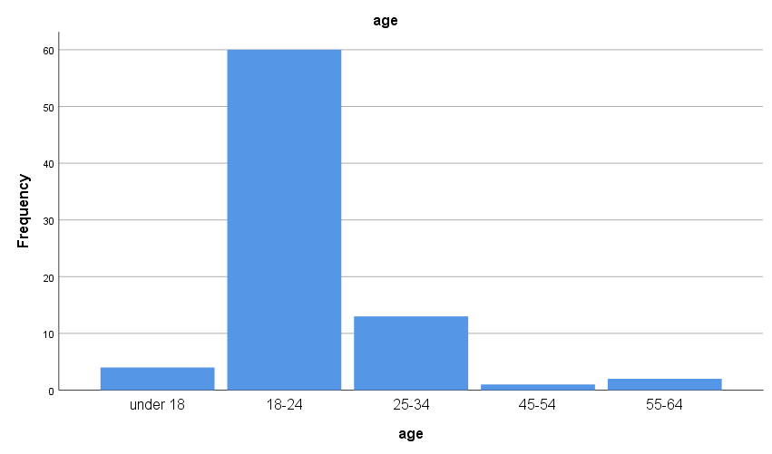

**Fig 5.1: Bar chart of Age**

**Interpretation:**

The data shows a concentration of participants in the 18-24 age group (75.0%), indicating a predominantly young adult sample. Older age groups, such as 25-34, 45-54, and 55-64, are less represented in the study. This suggests that the findings may be more applicable to younger demographics and may not fully represent older age cohorts’ perspectives on food delivery apps.

**Frequency of Gender**

|  |  |  |  |
| --- | --- | --- | --- |
| **gender** | | | |
|  | | Frequency | Percent | |
| Valid | female | 47 | 58.8 | |
| male | 33 | 41.3 | |
| Total | 80 | 100.0 | |

**Table 5.2: Gender**

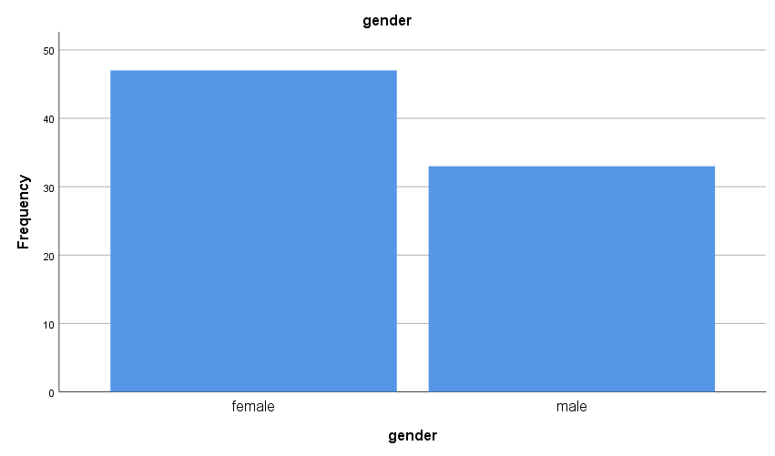

**Fig 5.2: Bar chart depicting Gender**

**Interpretation:**

The data provided presents the gender distribution of respondents in your survey on food delivery apps preferences. Among the data, 58.8% of respondents identify as female. This indicates a higher representation of females among the survey participants compared to males. 41.3% of respondents identify as male. While this group is smaller than the female respondents, it still represents a significant portion of the survey population. Overall, the data shows that females are slightly more represented than males in the survey regarding food delivery apps preferences. However, both genders are fairly well-represented in the study.

**Frequency of Location distribution**

|  |  |  |  |
| --- | --- | --- | --- |
| **location** | | | |
|  | | Frequency | Percent | |
| Valid | urban | 59 | 73.8 | |
| rural | 15 | 18.8 | |
| sub-urban | 6 | 7.5 | |
| Total | 80 | 100.0 | |

**Table 5.3: Location**

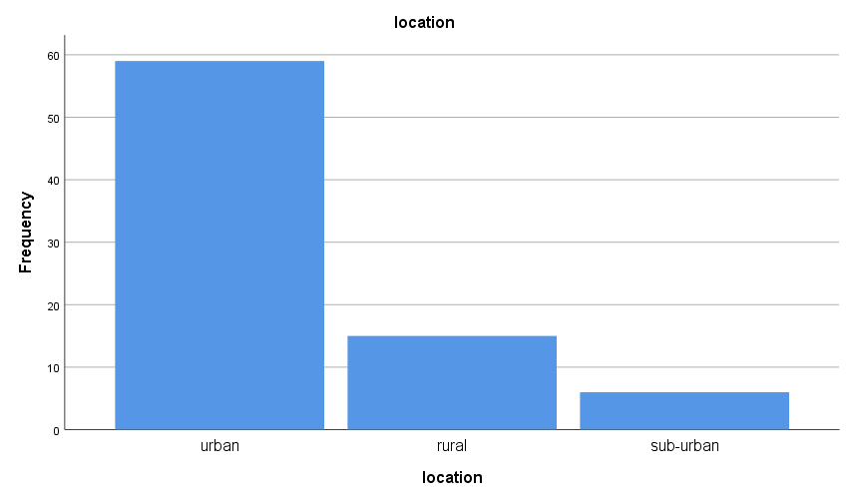

**Fig 5.3: Bar chart depicting Location**

**Interpretation:**

The data reveals that 73.8% of respondents are from urban areas, 18.8% are from rural areas, and 7.5% are from suburban areas. This indicates a higher representation of urban respondents in the survey on food delivery app preferences compared to rural and suburban participants.

**Frequency of Occupation**

|  |  |  |  |  |
| --- | --- | --- | --- | --- |
| **occupation** | | | | |
|  | | Frequency | Percent |
| Valid | Employed full-time | 16 | 20.0 |
| Employed part-time | 7 | 8.8 |
| Student | 55 | 68.8 |
| Unemployed | 2 | 2.5 |
| Total | 80 | 100.0 |

**Table 5.4: Occupation**

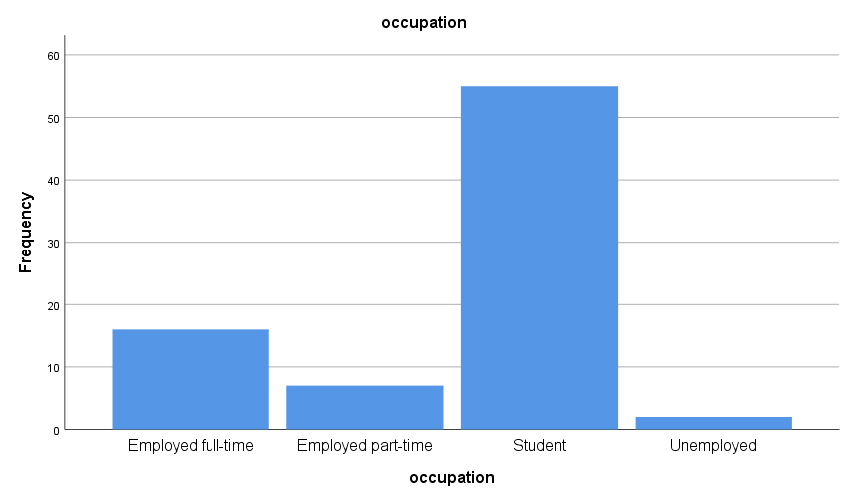

**Fig 5.4: Bar chart depicting Occupation**

**Interpretation:**

The occupation data shows that 68.8% of respondents are students, 20.0% are employed full-time, 8.8% are employed part-time, and 2.5% are unemployed. This suggests that students make up the majority of respondents in the survey on food delivery app preferences, followed by those employed full-time and part-time, with a smaller proportion being unemployed.

**Income Level Distribution**

|  |  |  |  |
| --- | --- | --- | --- |
| **Income level** | | | |
|  | | Frequency | Percent | |
| Valid | < 20K | 63 | 78.8 | |
| >20K TO <50K | 12 | 15.0 | |
| >50K TO <80K | 3 | 3.8 | |
| >80K | 2 | 2.5 | |
| Total | 80 | 100.0 | |

**Table 5.5: Income Level**

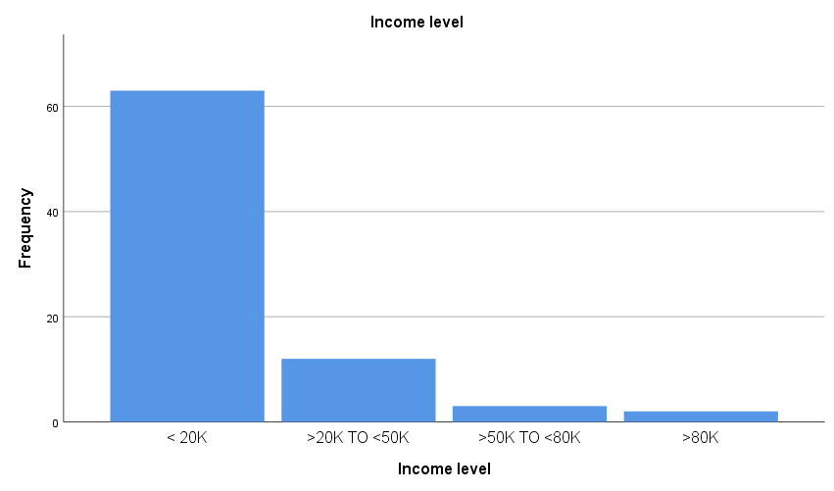

**Fig 5.5: Bar chart depicting Income level**

**Interpretation:**

The income level data indicates that 78.8% of respondents have an income less than $20,000, 15.0% have an income between $20,000 to $50,000, 3.8% have an income between $50,000 to $80,000, and 2.5% have an income exceeding $80,000. This suggests that the majority of respondents in the survey on food delivery app preferences have lower incomes, with fewer respondents having higher income levels.

**Usage of Food Delivery Apps**

|  |  |  |  |
| --- | --- | --- | --- |
| **Do you currently use any food delivery apps?** | | | |
|  | | Frequency | Percent | |
| Valid | yes | 80 | 100.0 | |

**Table 5.6: Usage of Apps**

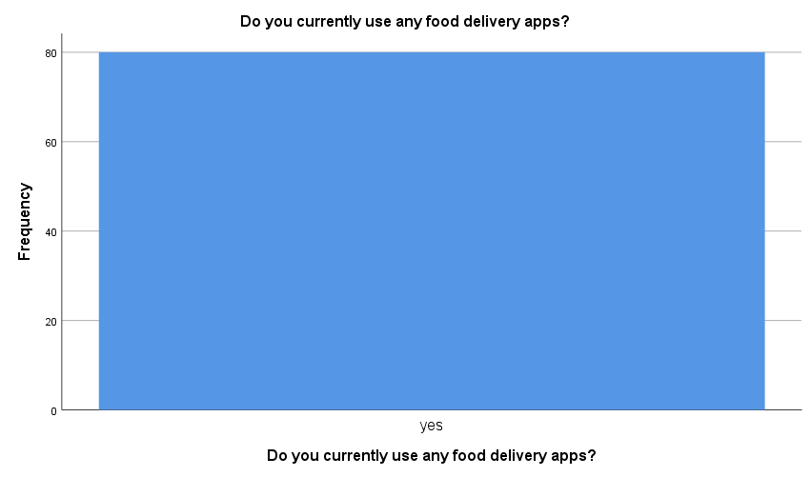

**Fig 5.6: Bar Chart showing usage**

**Interpretation:**

The data shows that 100% of respondents currently use food delivery apps. This indicates that all participants in the survey are users of food delivery apps.

**Choice of use of Apps**

|  |  |  |  |  |
| --- | --- | --- | --- | --- |
| **If yes, which ones do you use?** | | | | |
|  | | Frequency | Percent |
| Valid | swiggy | 36 | 45.0 |
| Zomato | 34 | 42.5 |
| FoodPanda | 1 | 1.3 |
| Uber Eats | 2 | 2.5 |
| Dominos | 6 | 7.5 |
| Kfc | 1 | 1.3 |
| Total | 80 | 100.0 |

**Table 5.7: Choice of apps**

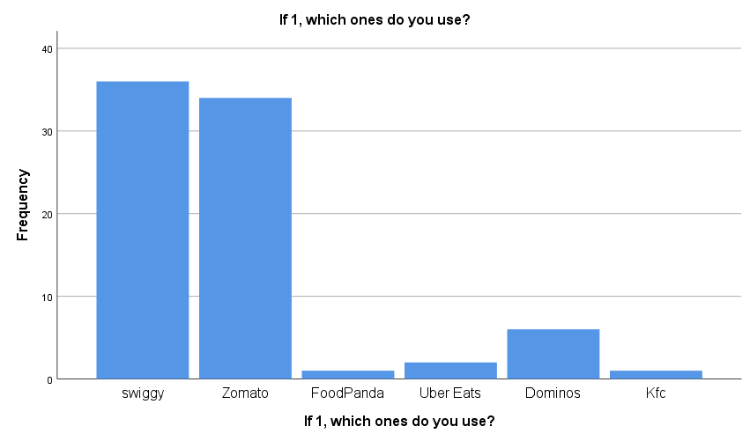

**Fig 5.7: Choice of Apps**

**Interpretation:**

The data shows that among respondents who use food delivery apps, 45.0% use Swiggy, 42.5% use Zomato, 7.5% use Domino's, 2.5% use Uber Eats, and 1.3% each use Food Panda, KFC, and another 1.3% use Zomato. This indicates that Swiggy and Zomato are the most popular food delivery apps among the surveyed users.

**Frequency of Usage**

|  |  |  |  |  |
| --- | --- | --- | --- | --- |
| **How often do you use food delivery apps in a typical week?** | | | | |
|  | | Frequency | Percent |
| Valid | Less than once a week | 47 | 58.8 |
| 1-2 times a week | 22 | 27.5 |
| 3-4 times a week | 10 | 12.5 |
| 5 or more times a week | 1 | 1.3 |
| Total | 80 | 100.0 |

**Table 5.8: Frequency of use of apps**

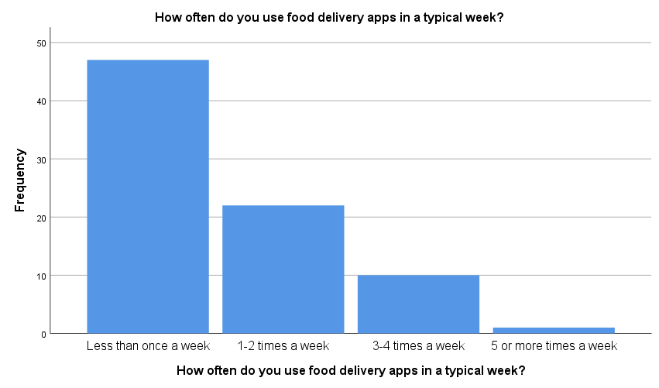

**Fig 5.8: Bar chart depicting frequency of usage**

**Interpretation:**

The interpretation of this data is that most users of food delivery apps in the survey use them infrequently, less than once a week. This could imply that while many people use these apps, they may not rely on them for daily meals but rather for occasional convenience or special occasions. On the other hand, a smaller but notable percentage of users do use food delivery apps more regularly, with 27.5% using them 1-2 times a week and 12.5% using them 3-4 times a week.

**Preferences of food**

|  |  |  |  |  |
| --- | --- | --- | --- | --- |
| **What types of food do you usually order through these apps?** | | | | |
|  | | Frequency | Percent |
| Valid | Fast food | 49 | 61.3 |
| Pizza | 16 | 20.0 |
| Asian cuisine | 4 | 5.0 |
| Italian cuisine | 2 | 2.5 |
| Mexican cuisine | 2 | 2.5 |
| Healthy options | 7 | 8.8 |
| Total | 80 | 100.0 |

**Table 5.9: Preferences of food**

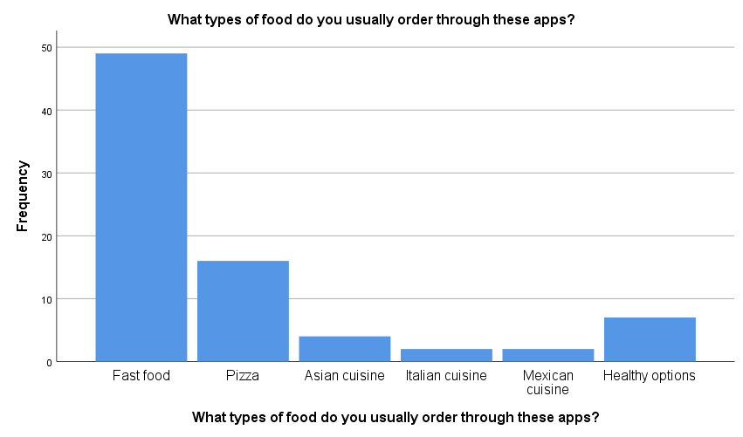

**Fig 5.9: Bar chart showing preferences of food**

**Interpretation:**

The data reveals that among respondents who use food delivery apps, the most commonly ordered types of food are fast food (61.3%), followed by pizza (20.0%), healthy options (8.8%), Asian cuisine (5.0%), Italian cuisine (2.5%), and Mexican cuisine (2.5%). This indicates a preference for quick and convenient food options like fast food and pizza, with a smaller but notable interest in healthier options and a variety of international cuisines.

**Frequency of comfort of ordering**

|  |  |  |  |  |
| --- | --- | --- | --- | --- |
| **How often do you order food delivery alone, family, friends, or colleagues?** | | | | |
|  | | Frequency | Percent |
| Valid | Alone | 20 | 25.0 |
| With family | 32 | 40.0 |
| With friends | 23 | 28.7 |
| With colleagues | 5 | 6.3 |
| Total | 80 | 100.0 |

**Table 5.10: Comfort**

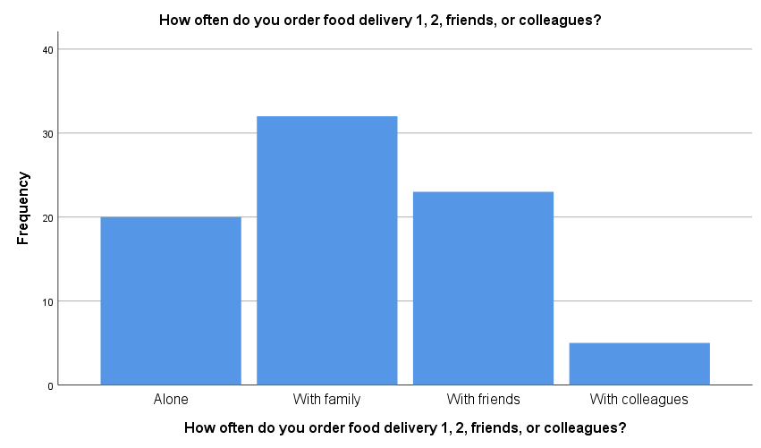

**Fig 5.10: Comfort of ordering**

**Interpretation:**

The data shows that among respondents who use food delivery apps, 25.0% order food delivery alone, 40.0% order with family, 28.7% order with friends, and 6.3% order with colleagues. This indicates that a significant portion of users prefer to order food delivery with their families, followed by ordering with friends, while a smaller percentage orders alone or with colleagues.

**Tendency of orders being placed:**

|  |  |  |  |  |
| --- | --- | --- | --- | --- |
| **How often do you tend to order food for special occasions or gatherings?** | | | | |
|  | | Frequency | Percent |
| Valid | Frequently | 15 | 18.8 |
| Occasionally | 36 | 45.0 |
| Rarely | 24 | 30.0 |
| Never | 5 | 6.3 |
| Total | 80 | 100.0 |

**Table 5.11: Tendency to order**

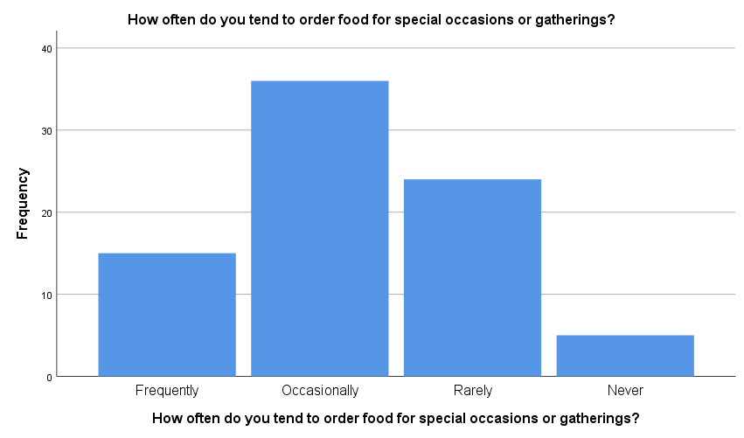

**Fig 5.11: Bar chart showing Tendency to order**

**Interpretation:**

The data indicates that among respondents who use food delivery apps, 18.8% frequently order food for special occasions or gatherings, 45.0% do so occasionally, 30.0% rarely do, and 6.3% never do. This suggests that a significant portion of users use food delivery services for special occasions or gatherings, with varying frequency levels ranging from frequent to rare usage.

**Problems faced by customers**

|  |  |  |  |
| --- | --- | --- | --- |
| **Have you experienced any problems with order accuracy, missing items, or delivery delays?** | | | |
|  | | Frequency | Percent |
| Valid | yes | 41 | 51.2 |
| no | 39 | 48.8 |
| Total | 80 | 100.0 |

**Table 5.12: Problems faced**

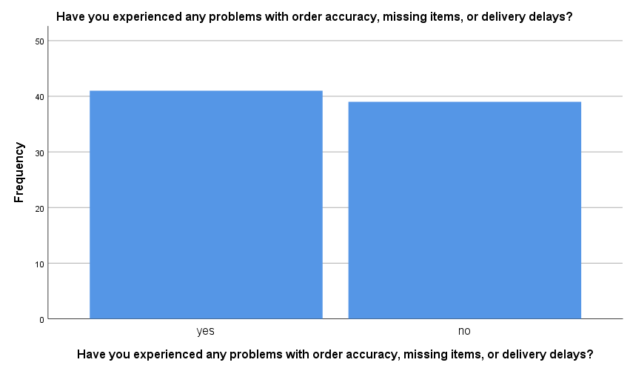

**Fig 5.12: Bar chart showing problems faced**

**Interpretation:**

The data shows that 51.2% of respondents have experienced problems with order accuracy, missing items, or delivery delays when using food delivery apps, while 48.8% have not encountered such issues. This indicates that a little over half of the users have faced problems related to order accuracy, missing items, or delivery delays at some point, highlighting areas that may need improvement in the food delivery app services.

**Features or Improvements in food delivery apps**

|  |  |  |  |
| --- | --- | --- | --- |
| **What features or improvements would you like to see in food delivery apps?** | | | |
|  | | Frequency | Percent |
| Valid | Manage menu (customizing spices) | 17 | 21.3 |
| Discount options for regular customers | 21 | 26.3 |
| Eat now pay later option | 16 | 20.0 |
| Group Orders | 14 | 17.5 |
| New order (customizing recipes) | 12 | 15.0 |
| Total | 80 | 100.0 |

**Table 5.13: Features or improvements**

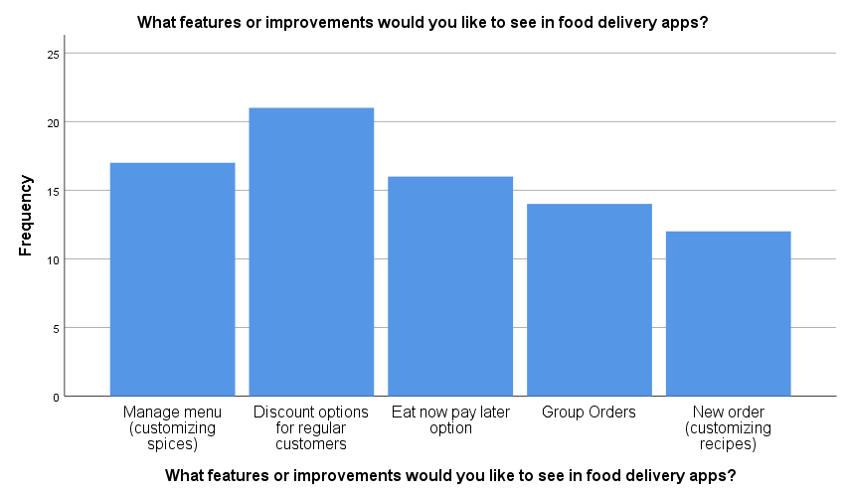

**Fig 5.13: Bar chart showing features or improvements**

**Interpretation:**

The data indicates that among respondents using food delivery apps, 26.3% would like to see discount options for regular customers, 21.3% are interested in managing menus with customizable spice options, 20.0% would like an "eat now pay later" option, 17.5% are interested in group orders features, and 15.0% would like a "new order" feature with customizable recipes. This suggests that users are interested in features that enhance customization, affordability, convenience in payment, and options for group ordering.

**Preference of a subscription-based model for food delivery apps**

|  |  |  |  |  |  |
| --- | --- | --- | --- | --- | --- |
| **Would you prefer a subscription-based model for food delivery apps (e.g., monthly fee for unlimited deliveries)?** | | | | | |
|  | | Frequency | Percent | Valid Percent | Cumulative Percent |
| Valid | yes | 48 | 60.0 | 60.0 | 60.0 |
| no | 32 | 40.0 | 40.0 | 100.0 |
| Total | 80 | 100.0 | 100.0 |  |

**Table 5.14: Preference of subscription model**

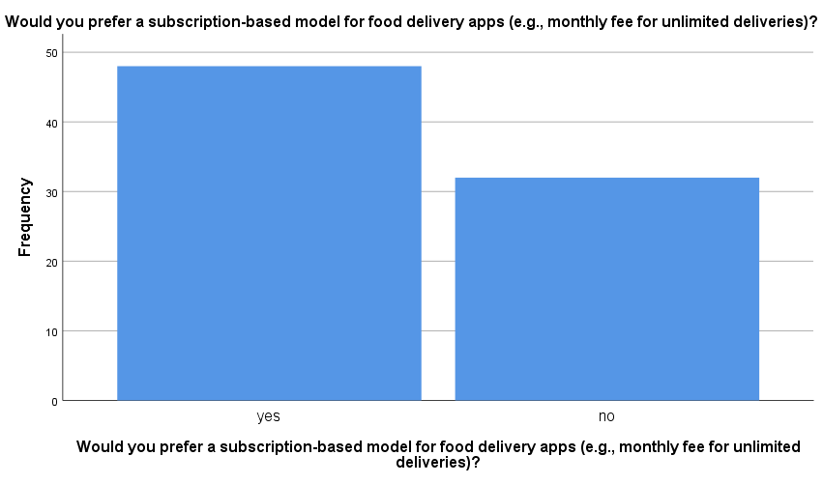

**Fig 5.14: Bar chart showing Preference of subscription model**

**Interpretation:**

The data shows that 60.0% of respondents would prefer a subscription-based model for food delivery apps, where they pay a monthly fee for unlimited deliveries. On the other hand, 40.0% of respondents prefer not to have a subscription-based model. This suggests that a majority of users are open to the idea of a subscription-based model for food delivery apps, which could provide them with more convenience and cost-effectiveness in their food ordering experience.

**Changes in food delivery app usage habits in the near future**

|  |  |  |  |
| --- | --- | --- | --- |
| **Do you foresee any changes in your food delivery app usage habits in the near future?** | | | |
|  | | Frequency | Percent |
| Valid | I plan to use food delivery apps more frequently. | 18 | 22.5 |
| I expect my food delivery app usage to remain about the same. | 28 | 35.0 |
| I anticipate using food delivery apps less frequently. | 15 | 18.8 |
| I am undecided; my food delivery app usage may change depending on circumstances. | 18 | 22.5 |
| I do not currently use food delivery apps and do not plan to start using them in the near future. | 1 | 1.3 |
| Total | 80 | 100.0 |

**Table 5.15: Changes in food delivery app usage habits**

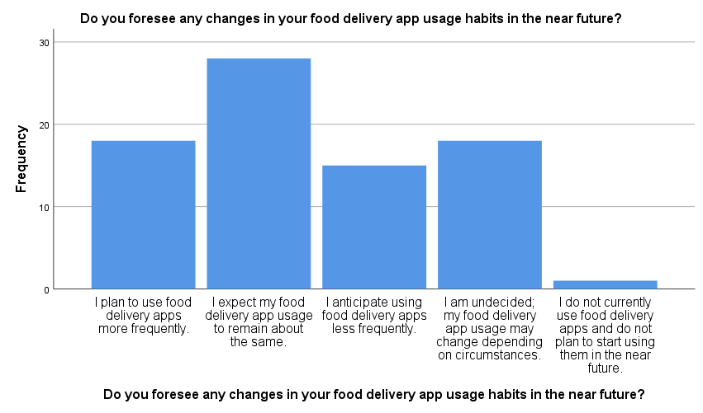

**Fig 5.15: Bar chart showing Changes in near future**

**Interpretation:**

The data reveals that among respondents regarding their food delivery app usage habits in the near future, 35.0% expect their usage to remain about the same, 22.5% plan to use food delivery apps more frequently, 22.5% are undecided and may change their usage depending on circumstances, 18.8% anticipate using food delivery apps less frequently, and 1.3% do not currently use food delivery apps and do not plan to start using them in the near future. This indicates a mixed outlook, with a significant portion expecting either an increase or decrease in their food delivery app usage, while others anticipate their usage to remain stable or are undecided.

**CHI SQUARE**

**Hypothesis:**

**Null Hypothesis (H0):** There is no significant relationship between age and the comfort of ordering during special occasions or gatherings.

**Alternate Hypothesis (H1):** There is significant relationship between age and comfort of ordering during special occasions or gatherings.

|  |  |  |  |  |  |  |
| --- | --- | --- | --- | --- | --- | --- |
| **age * How often do you tend to order food for special occasions or gatherings? Crosstabulation** | | | | | | |
| Count | | | | | | |
|  | | How often do you tend to order food for special occasions or gatherings? | | | | Total |
| Frequently | Occasionally | Rarely | Never |
| age | under 18 | 3 | 0 | 0 | 1 | 4 |
| 18-24 | 11 | 27 | 20 | 2 | 60 |
| 25-34 | 1 | 8 | 3 | 1 | 13 |
| 45-54 | 0 | 0 | 0 | 1 | 1 |
| 55-64 | 0 | 1 | 1 | 0 | 2 |
| Total | | 15 | 36 | 24 | 5 | 80 |

**Table 5.16: Age * Tendency to order food for special occasions or gatherings**

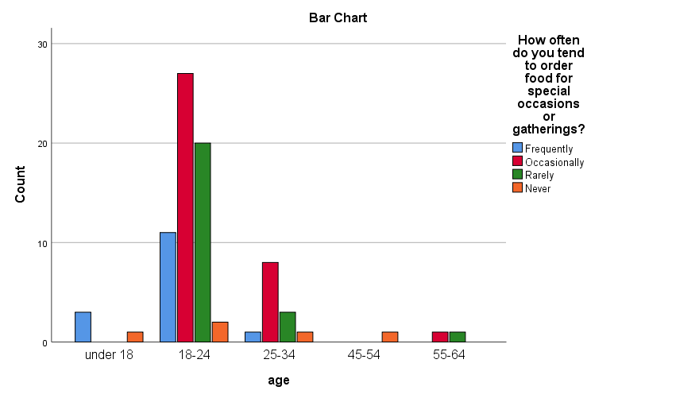

**Fig 5.16: Bar chart showing tendency to order food for special occasions or gatherings**

|  |  |  |  |
| --- | --- | --- | --- |
| **Chi-Square Tests** | | | |
|  | Value | df | Asymptotic Significance (2-sided) |
| Pearson Chi-Square | 30.711a | 12 | .002 |
| Likelihood Ratio | 21.141 | 12 | .048 |
| Linear-by-Linear Association | 2.874 | 1 | .090 |
| N of Valid Cases | 80 |  |  |

**Table 5.17: Chi square showing Tendency to order food for special occasions or gatherings with age**

**Interpretation:**

The chi-square tests conducted on the data revealed significant associations between variables related to food delivery app usage habits and other factors. The Pearson Chi-Square test yielded a statistic of 30.711 with 12 degrees of freedom and a **p-value of .002**, indicating strong evidence to **reject the null hypothesis**. Hence Null hypothesis (H0) is rejected. There is significant relationship between age and comfort to order food for special occasions or gatherings.

These findings suggest that factors such as changes in usage frequency are likely influenced by or have an influence on other variables examined in the survey. Further exploration of these associations could provide valuable insights into consumer behaviors and preferences regarding food delivery apps, aiding in strategic decision-making and market analysis within the industry.

**Null Hypothesis (H0):** There is no significant relationship between importance of factors of food delivery apps and satisfaction.

**Alternate Hypothesis (H1):** There is significant relationship between importance of factors of food delivery apps and satisfaction.

|  |  |  |  |
| --- | --- | --- | --- |
| **Chi-Square Tests** | | | |
|  | Value | df | Asymptotic Significance (2-sided) |
| Pearson Chi-Square | 119.155a | 98 | .072 |
| Likelihood Ratio | 90.105 | 98 | .703 |
| Linear-by-Linear Association | 10.596 | 1 | .001 |
| N of Valid Cases | 80 |  |  |

**Table 5.18: Association between factors and satisfaction**

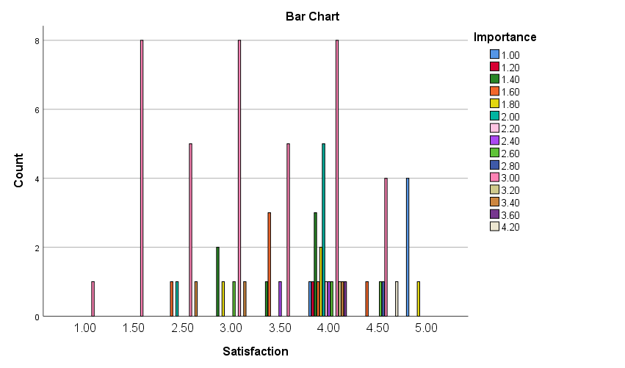

**Fig 5.17: Bar chart showing Association between factors and satisfaction**

**Interpretation:**

The test statistic is 119.155 with 98 degrees of freedom and a p-value of .072. This p-value suggests that there is no statistically significant association between the variables at the conventional significance level of .05. This p-value also indicates that there is no significant association between the variables based on the likelihood ratio test. Hence Null hypothesis (H0) is accepted. This p-value is statistically significant at the .05 level, suggesting a potential linear trend in the association between the variables.

Based on these results, we can conclude that while there may be a linear trend in the association between some variables, the overall chi-square tests do not show a significant association between the variables at the conventional significance level.

**RELIABILITY TEST**

|  |  |  |  |
| --- | --- | --- | --- |
| **Case Processing Summary** | | | |
|  | | N | % |
| Cases | Valid | 80 | 100.0 |
| Excluded | 0 | .0 |
| Total | 80 | 100.0 |
| a. Listwise deletion based on all variables in the procedure. | | | |

**Table 5.19: Reliability case summary**

|  |  |
| --- | --- |
| **Reliability Statistics** | |
| Cronbach's Alpha | N of Items |
| .701 | 7 |

**Table 5.20: Reliability test statistics**

**Interpretation**

The reliability analysis conducted using Cronbach's Alpha yielded a value of .701, indicating a moderate level of internal consistency among the items measured. With seven items included in the analysis, this level of reliability suggests that the items in the scale are reasonably consistent in measuring the underlying construct. While a Cronbach's Alpha of .701 is generally considered acceptable, it's important to note that higher values (typically above .70 or .80) are preferred for greater confidence in the reliability of the scale. Therefore, while the reliability is moderate, there may be room for improvement in refining the scale or adding more items to enhance its internal consistency.

**T-TEST**

**Null Hypothesis (H0):** There is no significant difference in the mean importance of access to location and experience of customers in facing any problems related to order accuracy, missing items, or delivery delays.

**Alternative Hypothesis (H1):** There is a significant difference in the mean importance of access to location and experience of customers in facing any problems related to order accuracy, missing items, or delivery delays.

|  |  |  |  |  |
| --- | --- | --- | --- | --- |
| **One-Sample Statistics** | | | | |
|  | N | Mean | Std. Deviation | Std. Error Mean |
| location | 80 | 1.34 | .615 | .069 |
| Have you experienced any problems with order accuracy, missing items, or delivery delays? | 80 | 1.49 | .503 | .056 |

**Table 5.21: Descriptive statistics between location and experience of customers**

|  |  |  |  |  |  |  |
| --- | --- | --- | --- | --- | --- | --- |
| **One-Sample Test** | | | | | | |
|  | Test Value = 0 | | | | | |
| t | df | Sig. (2-tailed) | Mean Difference | 95% Confidence Interval of the Difference | |
| Lower | Upper |
| location | 19.449 | 79 | .000 | 1.338 | 1.20 | 1.47 |
| Have you experienced any problems with order accuracy, missing items, or delivery delays? | 26.451 | 79 | .000 | 1.488 | 1.38 | 1.60 |

**Table 5.22: One sample test between location and experience of customers**

**ANOVA**

**Null Hypothesis (H0):** There is no significant association between the respondents' preference on payment and their income.

**Alternative Hypothesis (H1):** There is a significant association between the respondents' preference on payment and their income.

|  |  |  |  |  |  |
| --- | --- | --- | --- | --- | --- |
| **ANOVA** | | | | | |
| What payment methods do you prefer to use when ordering food through delivery apps? | | | | | |
|  | Sum of Squares | df | Mean Square | F | Sig. |
| Between Groups | .610 | 3 | .203 | .118 | .949 |
| Within Groups | 131.190 | 76 | 1.726 |  |  |
| Total | 131.800 | 79 |  |  |  |

**Table 5.23: ANOVA test between respondents' preference on payment and their income.**

|  |  |  |  |  |  |  |
| --- | --- | --- | --- | --- | --- | --- |
| **Multiple Comparisons** | | | | | | |
| Dependent Variable: What payment methods do you prefer to use when ordering food through delivery apps? | | | | | | |
| Tukey HSD | | | | | | |
| (I) Income level | (J) Income level | Mean Difference (I-J) | Std. Error | Sig. | 95% Confidence Interval | |
| Lower Bound | Upper Bound |
| < 20K | >20K TO <50K | -.119 | .414 | .992 | -1.21 | .97 |
| >50K TO <80K | .381 | .776 | .961 | -1.66 | 2.42 |
| >80K | .048 | .944 | 1.000 | -2.43 | 2.53 |
| >20K TO <50K | < 20K | .119 | .414 | .992 | -.97 | 1.21 |
| >50K TO <80K | .500 | .848 | .935 | -1.73 | 2.73 |
| >80K | .167 | 1.003 | .998 | -2.47 | 2.80 |
| >50K TO <80K | < 20K | -.381 | .776 | .961 | -2.42 | 1.66 |
| >20K TO <50K | -.500 | .848 | .935 | -2.73 | 1.73 |
| >80K | -.333 | 1.199 | .992 | -3.48 | 2.82 |
| >80K | < 20K | -.048 | .944 | 1.000 | -2.53 | 2.43 |
| >20K TO <50K | -.167 | 1.003 | .998 | -2.80 | 2.47 |
| >50K TO <80K | .333 | 1.199 | .992 | -2.82 | 3.48 |

**Table 5.24: Tukey HSD between respondents' preference on payment and their income.**

**Interpretation:**

The ANOVA results for the preferred payment methods when ordering food through delivery apps indicate that there is no statistically significant difference between the groups based on payment methods, as evidenced by the p-value of .949, which is greater than the conventional significance level of .05

In conclusion, the ANOVA analysis does not support rejecting the null hypothesis, indicating that there is no significant difference in preferred payment methods among respondents when ordering food through delivery apps. This suggests that factors other than payment methods may play a more substantial role in users' decisions or preferences regarding food delivery app usage.

**CORRELATION**

**Null Hypothesis (H0):** There is no significant association between gender and types of food customers order through apps.

**Alternative Hypothesis (H1):** There is a significant association between gender and types of food customers order through apps.

|  |  |  |  |
| --- | --- | --- | --- |
| **Correlations** | | | |
|  | | gender | What types of food do you usually order through these apps? |
| gender | Pearson Correlation | 1 | .015 |
| Sig. (2-tailed) |  | .898 |
| N | 80 | 80 |
| What types of food do you usually order through these apps? | Pearson Correlation | .015 | 1 |
| Sig. (2-tailed) | .898 |  |
| N | 80 | 80 |

**Table 5.25: Correlation between gender and types of food customers order through apps.**

**Interpretation:**

The correlation analysis between gender and the types of food usually ordered through food delivery apps yielded a Pearson correlation coefficient of .015 with a **p-value of .898**. These results indicate a very weak and statistically non-significant correlation between gender and food preferences when ordering through these apps.

In other words, there is no meaningful relationship or association between a person's gender and the types of food they typically order using food delivery apps. Thus, **Null Hypothesis (H0) is accepted**. This implies that gender does not significantly influence the food choices made by users when using food delivery services.

**REGRESSION**

**Null Hypothesis (H0):** There is no significant association between the respondents' preference on payment and their income.

**Alternative Hypothesis (H1):** There is a significant association between the respondents' preference on payment and their income.

|  |  |  |  |  |
| --- | --- | --- | --- | --- |
| **Model Summaryb** | | | | |
| Model | R | R Square | Adjusted R Square | Std. Error of the Estimate |
| 1 | .018a | .000 | -.013 | 1.300 |
| a. Predictors: (Constant), Income level | | | | |
| b. Dependent Variable: What payment methods do you prefer to use when ordering food through delivery apps? | | | | |

**Table 5.26: Model summary of regression between respondents' preference on payment and their income**

|  |  |  |  |  |  |  |
| --- | --- | --- | --- | --- | --- | --- |
| **Coefficientsa** | | | | | | |
| Model | | Unstandardized Coefficients | | Standardized Coefficients | t | Sig. |
| B | Std. Error | Beta |
| 1 | (Constant) | 3.095 | .321 |  | 9.636 | .000 |
| Income level | -.034 | .220 | -.018 | -.157 | .876 |
| a. Dependent Variable: What payment methods do you prefer to use when ordering food through delivery apps? | | | | | | |

**Table 5.27: Coefficient of regression analysis between respondents' preference on payment and their income**

**Interpretation**

The regression analysis aimed to determine the relationship between income level and preferred payment methods when ordering food through delivery apps. The results show p-value of .876. This suggests that there is no significant linear relationship or association between income level and preferred payment methods among respondents using food delivery apps. Thus, **Null Hypothesis (H0) is accepted** which posits that there is no significant relationship between income level and preferred payment methods when ordering food through delivery apps.

**FINDINGS**

**Here are the findings based on the data:**

Chi-Square Tests:

The chi-square tests indicated a statistically significant association between the variables related to food delivery app usage habits and other factors. Specifically, the Linear-by-Linear Association test showed a significant result with a p-value of .001, suggesting a potential linear trend in the association between some variables. However, the overall Pearson Chi-Square and Likelihood Ratio tests did not show significant associations at the conventional significance level.

Reliability Statistics:

The Cronbach's Alpha reliability analysis yielded a value of .701, indicating a moderate level of internal consistency among the items measured. While this level of reliability is generally acceptable, higher values are preferred for greater confidence in the scale's reliability.

ANOVA:

The ANOVA results for preferred payment methods did not show a statistically significant difference between the groups based on payment methods. The p-value of .949 indicated that there was no significant association between preferred payment methods and other factors examined in the survey.

Correlations:

The correlation analysis between gender and types of food ordered through food delivery apps revealed a very weak and statistically non-significant correlation, with a correlation coefficient of .015 and a p-value of .898. This suggests that gender does not significantly influence food preferences when using food delivery services.

Regression:

The regression analysis examining the relationship between income level and preferred payment methods did not find a significant linear relationship. The coefficients for income level were not statistically significant, indicating that income level does not significantly predict preferred payment methods among users of food delivery apps.

Overall, the findings suggest mixed results regarding the associations between different variables related to food delivery app usage, payment methods, and user preferences.